Portland Press R&P workflow for authors

- Author submits their paper to any Portland Press journal.
- Author validates their institutional affiliation during submission and is immediately told if they are eligible to publish under an R&P agreement.
- R&P article is automatically published open access upon acceptance without the need for any additional payment or funding approval. *

* For this process to be fully automatic and not require individual approval for each paper the “auto approval” functionality in RightsLink must be enabled. Instructions on how to do this are included at the end of this document.

Step by step
Authors can submit their work to any Portland Press journal. During the submission process authors are asked to validate their affiliation by clicking on the link “Validate Institution”.
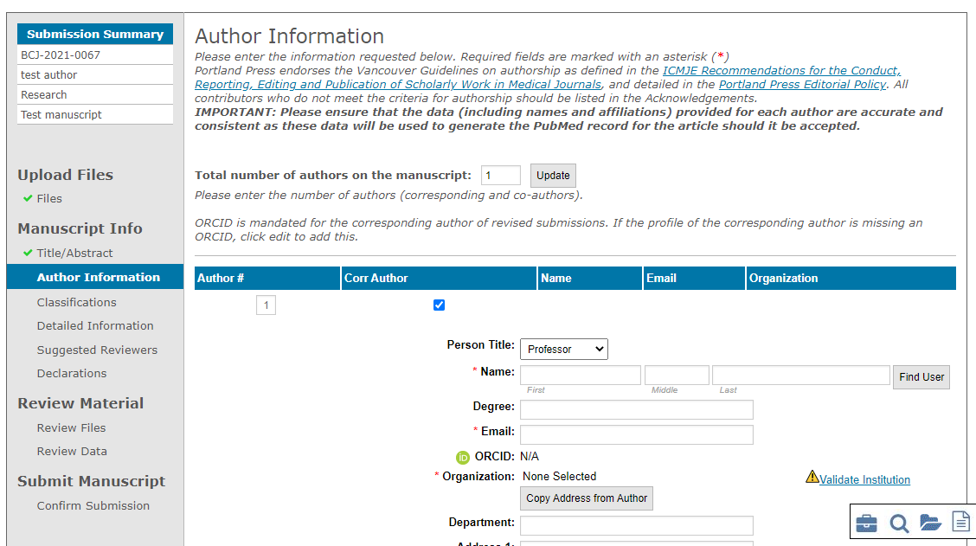

This brings up a new window where authors can search for their institution.

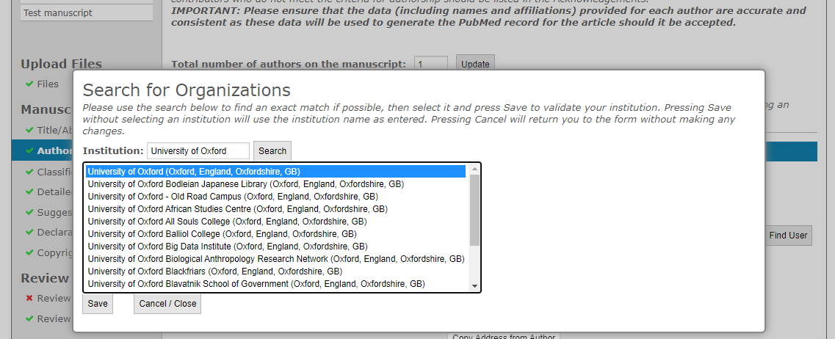
Selecting the correct institution and clicking Save will validate the affiliation and a green tick will appear on the right-hand side.

Once the author progresses to the Detailed Information tab of the submission form the system will check the author’s affiliation against the list of institutional agreements in RightsLink. If the institution holds an active R&P agreement with Portland Press the author will be made aware of this immediately.

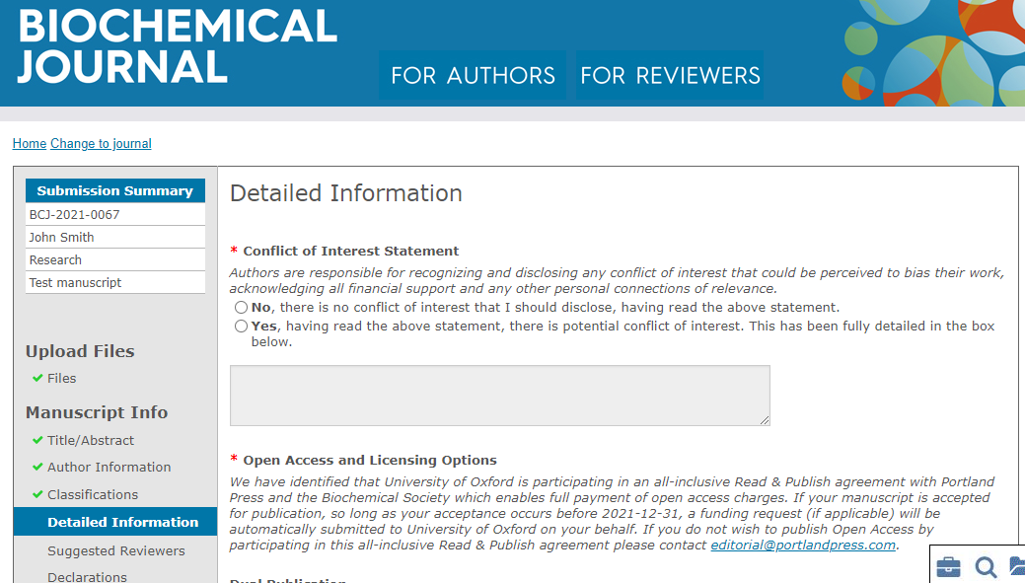

During subsequent revisions our editorial system will keep checking and notify the author of any changes to their eligibility (e.g., if the initial R&P agreement expired or a new institution signed up and an author’s paper thus became eligible during the review/revision process). Where an agreement mandates that authors publish under a specific license type this will automatically be presented to them during revision.

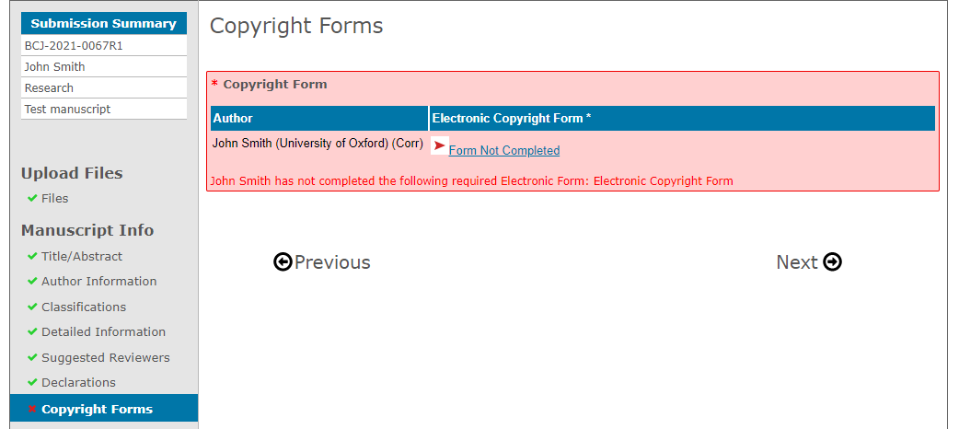

Furthermore, e-mail correspondences with the author at submission, revision and acceptance will also refer to an author’s R&P eligibility.

Once accepted, articles will be visible to librarians in the RightsLink institutional portal. If auto approvals are switched on then no action needs to be taken, otherwise each funding request will need to be manually approved in the portal.

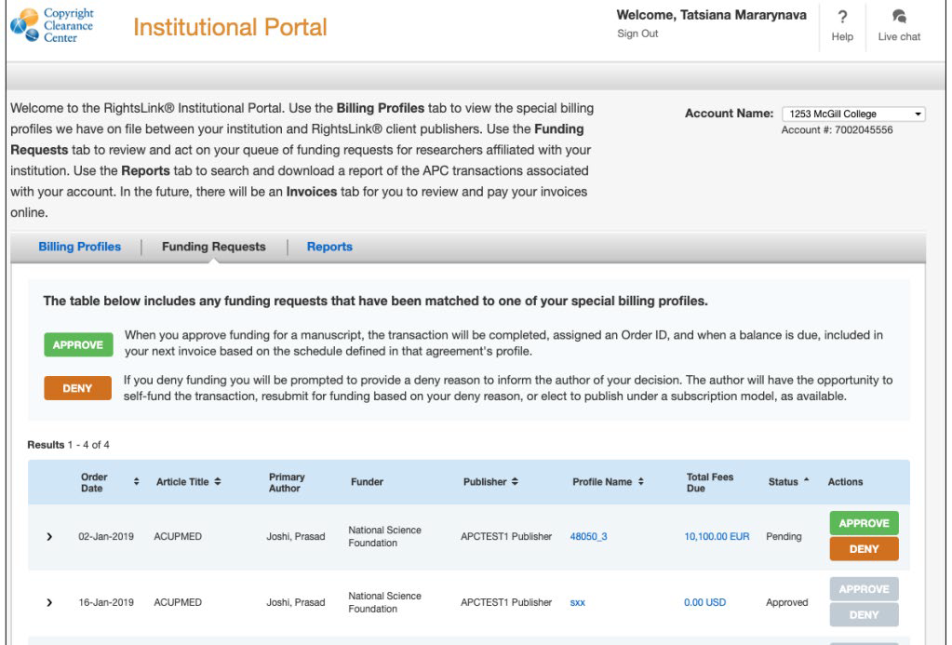

As our agreements are not limited by number of articles, we do recommend that institutions enable the auto-approval functionality as per the below instructions.
- Log in to your RightsLink Institutional Portal and navigate to the “Billing Profiles” tab.
- Find your agreement with Portland Press (“Portland Press” will be shown under the “Publisher” column) and click the box under “Automatic Approvals” as shown in the screenshot below.

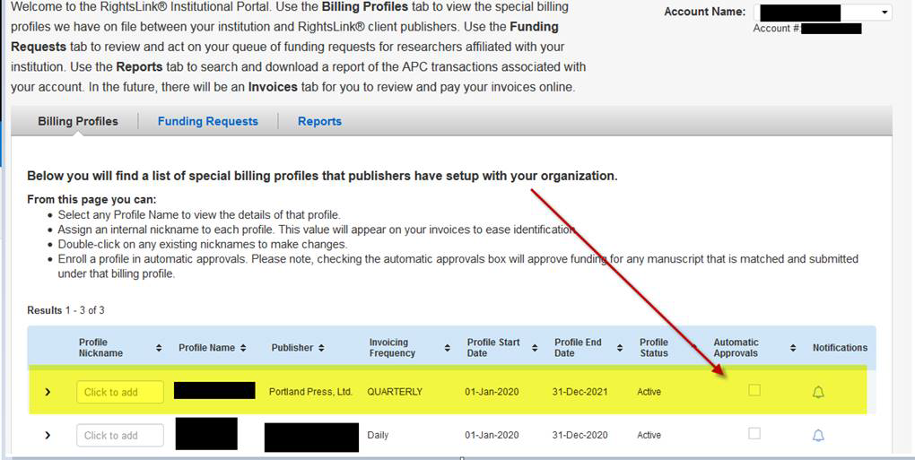
Further details about this and other functionalities can be found on the Institution Agreement Management Resources page, and in the Institutional Portal Guide (pdf) . It is recommended that new users familiarize themselves with the information available here.

If you have any questions around using the portal or about your agreement with Portland Press please contact sales@portlandpress.com.

